Question9_1



Question9_2



Question9_3

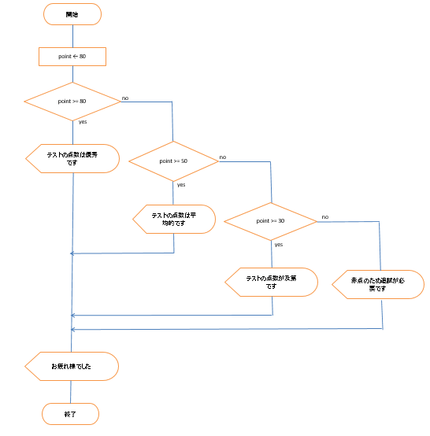

Question10_1



Question10_4